- Workflow Screenshot
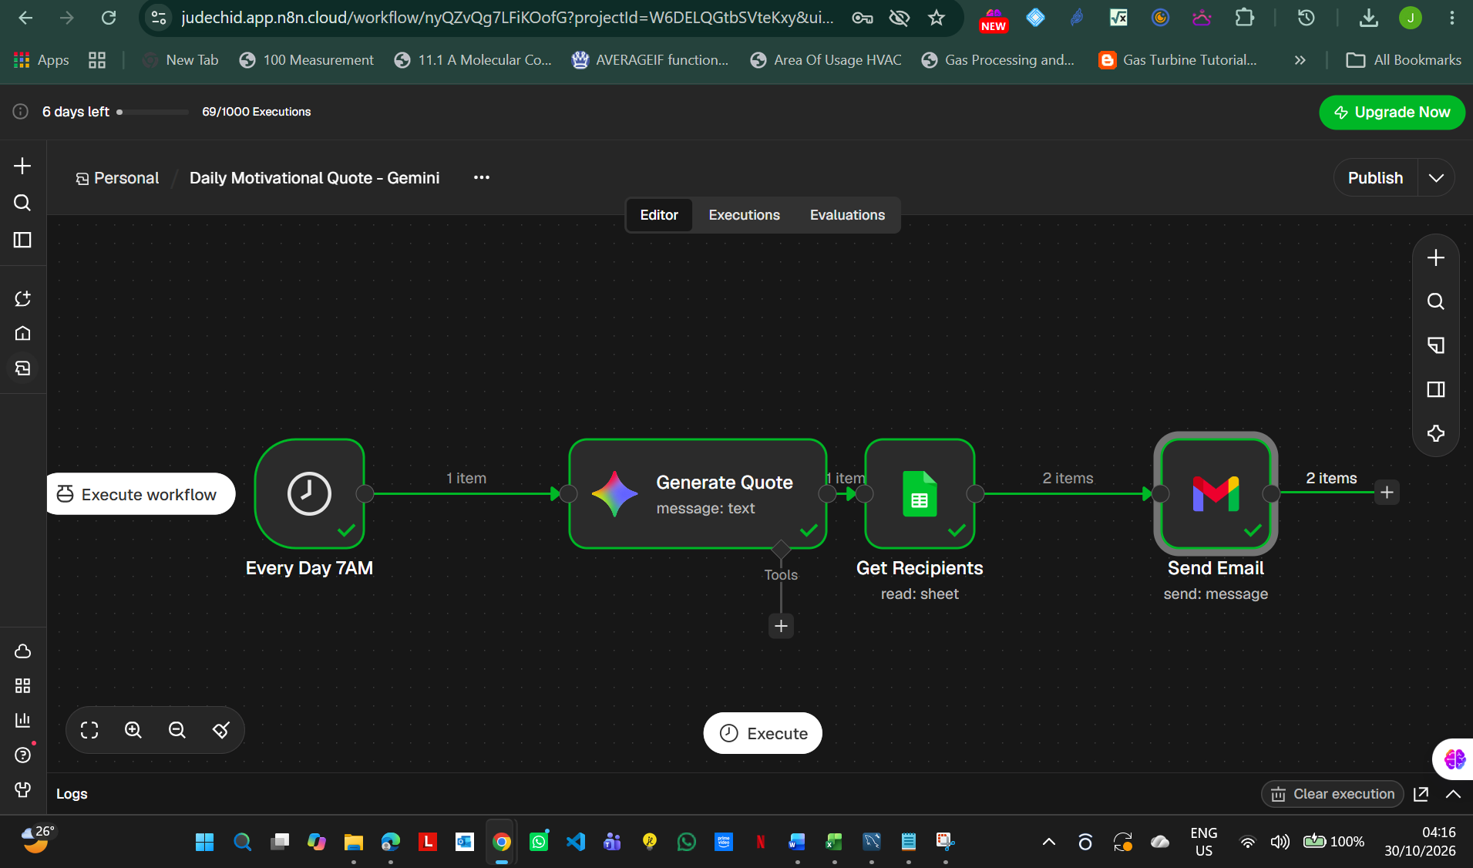
- Screenshot of Successful email delivery
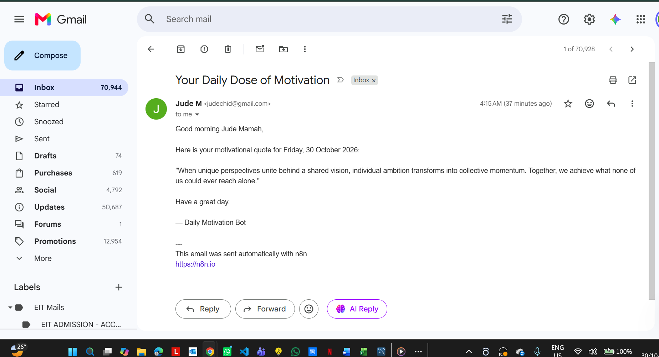
- Google sheet Used
https://docs.google.com/spreadsheets/d/1wAhADiR2ZGS1MmRvI42yJH-1L5JlhSIHoxHXDmqpRdo/edit?usp=sharing
- Video of How the Workflow works
https://docs.google.com/document/d/1VHSu_hR-DT8mwyxOGzTinS_zUTVdneUq/edit?usp=sharing&ouid=106280975417132381559&rtpof=true&sd=true

